Zoom – Video Conferencing Guide

✅ How to Show Up on Zoom
- Camera ON – Unless explicitly stated otherwise
- Dress the Part – Business casual for internal, business professional for client-facing
- No Eating on Zoom – Grab your snack before or after
- Look at the Camera – Not your second screen, not your phone
- Sit Up, Frame Up – Eye-level camera, shoulders centered, background clean
- Mute When Not Speaking – Always

🎥 Zoom Setup Essentials
- Backgrounds: Use Balefire-approved backgrounds (preloaded in Zoom Workplace – make sure you're signed in)
- Lighting: Face a light source; avoid backlighting
- Environment: Quiet, neutral, no clutter, no beds
- Headphones recommended for clear audio

👎 Avoid:
- Multitasking
- Slouching or looking down
- Distracting movement or side chatter
- Using reactions/emojis in client meetings
- Leaving your mic on when you're not talking

📸 Visual Reference:
Attached is an image showing correct posture, lighting, camera angle, and appropriate background
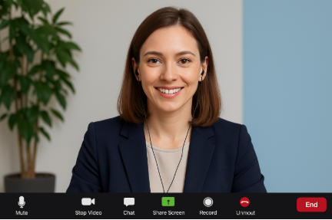
For background help or visual questions, reach out to Marketing or Operations Support. Let’s show up polished and prepared — every time.

