LinkedIn Setup & Best Practices Guide
Maintaining a strong and consistent LinkedIn presence helps amplify Balefire’s brand, reinforces credibility, and aligns with our professional standards. Please use the guide below to optimize your personal LinkedIn profile as a Balefire team member.

✅ 1. Profile Banner & Photo
- Banner Image:
Update your cover image using the official Balefire banner:
📸 Click here to download
To upload: Click the pencil icon on the upper right of the banner > “Change photo” > Upload.
- Profile Photo:
Use your professional photo taken by Balefire or schedule one during onboarding. This should be the only profile photo used to reflect consistency.

📇 2. Contact Information
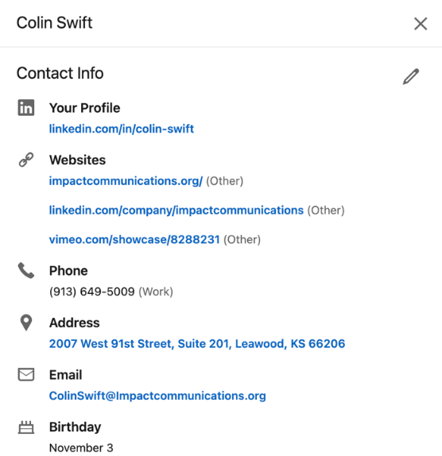
- Click on contact info on your profile page and then click on the pencil in the upper right corner

- Add or confirm:
  - Website: https://www.balefirewealth.com
  - Company LinkedIn: Balefire LinkedIn Page
  - Office Address: Use your office’s street address
  - Phone: Use your Zoom phone number unless you prefer to publish your personal cell
- Custom URL: Update your LinkedIn URL to: linkedin.com/in/firstname-lastname or include professional designations if needed (e.g., /in/jane-smith-cfp).

📝 3. Profile Introduction & Services
- Click on the pencil in the upper right of the profile intro section
- 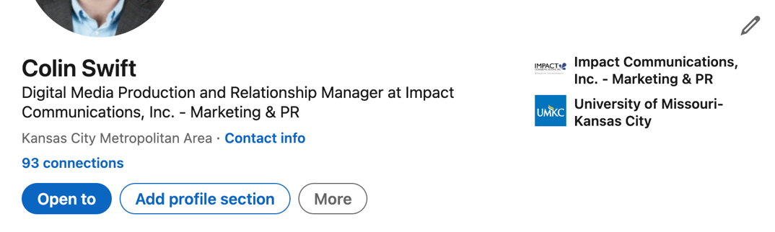
- Ensure the “Intro” section (headline, location, industry, etc.) reflects your role at Balefire.
- Click “Open to” > “Providing services”:
  - Highlight up to 10 services aligned with your role and Balefire’s offerings (e.g., Financial Planning, Investment Management, Retirement Solutions, etc.)

👤 4. About Section
Copy and paste the bio from your Balefire team webpage into your About section. This ensures messaging consistency and clarity. If you did not submit information previously in order to have a bio created, please reach out to Stephanie Elton: selton@balefirewealth.com

- If you would like to use something else alternatively, please submit for approval to Mark Oswald: moswald@balefirewealth.com

💼 5. Experience
- Current Role: Ensure your role is listed under the correct Balefire company profile with the official logo.
- Company Description: Use the official language from Balefire’s LinkedIn “About” section or the company website.
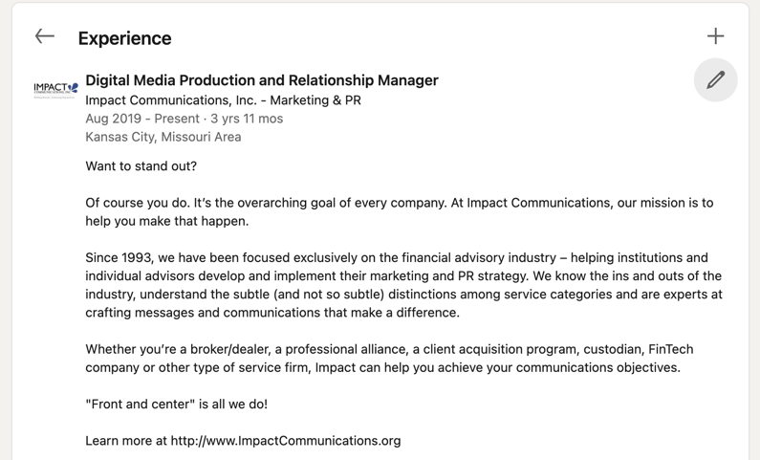
- Include any past roles if applicable, maintaining professional tone and alignment.
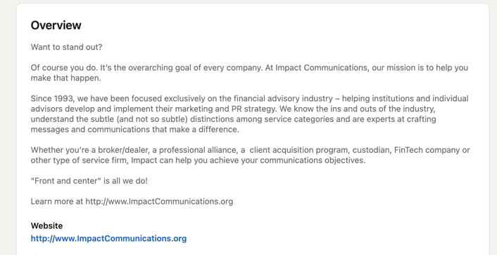

🎓 6. Education & Certifications
- Confirm all schools are linked to their correct university pages with matching logos.
- Add:
  - Certifications (e.g., CFP®, CPA, AIF®)
  - Registrations (e.g., FINRA Series 65)
  - Any internal Balefire training/certifications in development

💡 7. Skills
- Maximize your skill section with relevant capabilities to your position and Balefire’s mission. Suggested skills include:
  - Financial Planning
  - Portfolio Management
  - Wealth Advisory
  - Retirement Plans
  - Insurance Planning
  - Client Experience
  - FinTech Tools (e.g., Orion, Practifi, eMoney)
- Look to leadership profiles for additional inspiration.

📰 8. Interests
- Follow:
  - Balefire’s company page (Required)
  - Leadership profiles at Balefire
  - Industry publications: Barron’s, InvestmentNews, WealthManagement.com
  - Key FinTech vendors: Orion, eMoney, Salesforce, Practifi
  - Personal interests and causes (to reflect your “pro-personal” self)

🔐 9. Settings & Privacy
- Set your @balefirewealth.com email as your primary LinkedIn email. (The one that is shared in your contact info)
- Adjust visibility settings to ensure your profile is searchable and fully public — this supports credibility and networking across the industry.

🤝 10. Building Connections
- Connect with:
  - All Balefire team members (check “People” tab on the Balefire page)
  - Industry peers, referral partners, vendors
  - Clients (as appropriate and compliant)
As a reminder: We are a relationship-driven firm — proactively maintaining a professional presence strengthens our network and firm reputation.

🔁 Ongoing Expectations
- Review and update your profile every 6 months
- Share or react to Balefire content when relevant

